**Interaction Terms**

In the previous video, you were introduced to how you might interpret interactions, and how you might observe the need for an interaction in your model.

Mathematically, an interaction is created by multiplying two variables by one another and adding this term to our linear regression model.

**[[](https://classroom.udacity.com/nanodegrees/nd025/parts/6e560cfc-9d0b-4f87-a980-1bf4003b4bc5/modules/e4508dac-d083-427b-be3d-63663aeada68/lessons/49462f74-b030-4bb6-bf67-8281c9181404/concepts/9814e26c-2845-4d09-bf4f-c8d0b4a417de)](https://classroom.udacity.com/nanodegrees/nd025/parts/6e560cfc-9d0b-4f87-a980-1bf4003b4bc5/modules/e4508dac-d083-427b-be3d-63663aeada68/lessons/49462f74-b030-4bb6-bf67-8281c9181404/concepts/9814e26c-2845-4d09-bf4f-c8d0b4a417de)**

The example from the previous video used **area** (x1*x*1​) and the **neighborhood** (x2*x*2​) of a home (either **A** or **B**) to predict the home **price** (y*y*). At the top of the screen in the video, you might have noticed the equation for a linear model using these variables as:

y^=b0+b1x1+b2x2*y*^​=*b*0​+*b*1​*x*1​+*b*2​*x*2​

This example does not involve an interaction term, and this model is appropriate if the relationship of the variables looks like that in the plot below.

**[[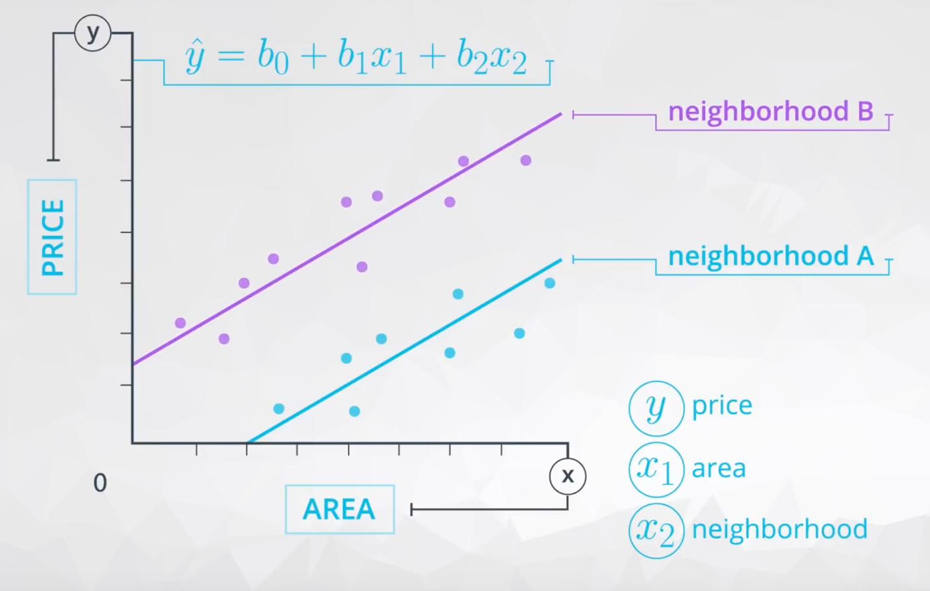](https://classroom.udacity.com/nanodegrees/nd025/parts/6e560cfc-9d0b-4f87-a980-1bf4003b4bc5/modules/e4508dac-d083-427b-be3d-63663aeada68/lessons/49462f74-b030-4bb6-bf67-8281c9181404/concepts/9814e26c-2845-4d09-bf4f-c8d0b4a417de)](https://classroom.udacity.com/nanodegrees/nd025/parts/6e560cfc-9d0b-4f87-a980-1bf4003b4bc5/modules/e4508dac-d083-427b-be3d-63663aeada68/lessons/49462f74-b030-4bb6-bf67-8281c9181404/concepts/9814e26c-2845-4d09-bf4f-c8d0b4a417de)**

where  b1*b*1​ is the way we estimate the relationship between **area** and **price**, which in this model we believe to be the same regardless of the neighborhood.

Then b2*b*2​ is the difference in price depending on which neighborhood you are in, which is the **vertical**distance between the two lines here:

**[[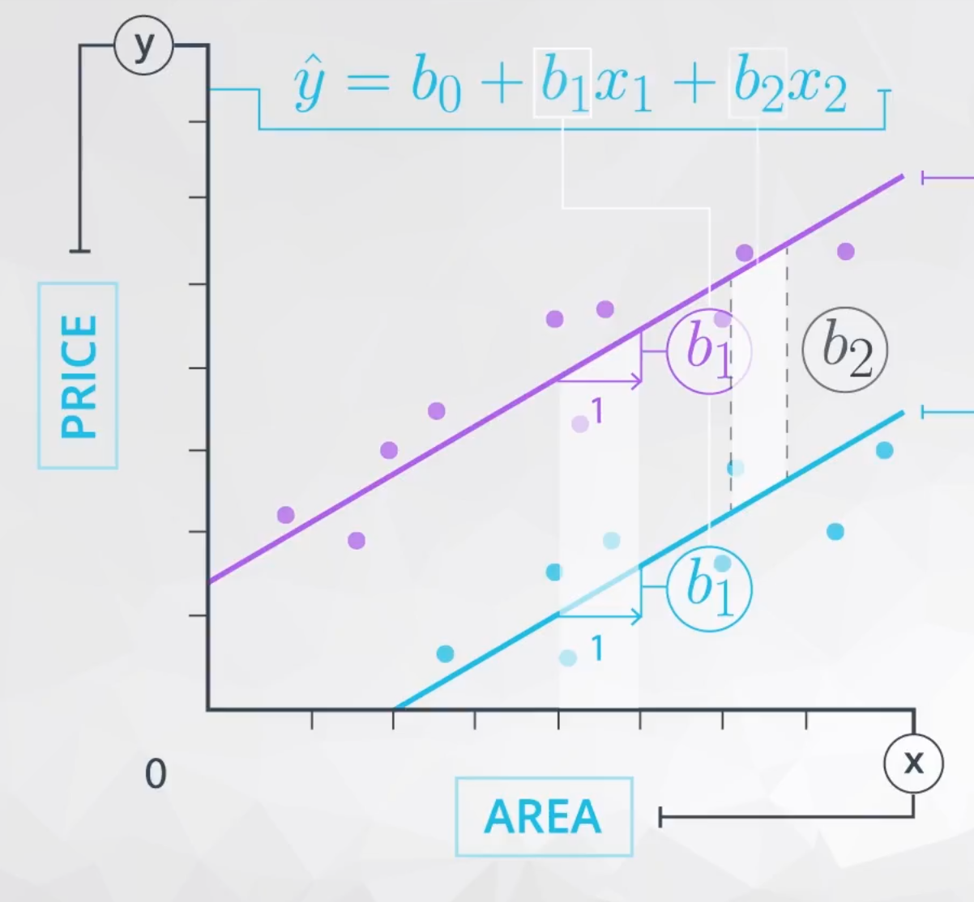](https://classroom.udacity.com/nanodegrees/nd025/parts/6e560cfc-9d0b-4f87-a980-1bf4003b4bc5/modules/e4508dac-d083-427b-be3d-63663aeada68/lessons/49462f74-b030-4bb6-bf67-8281c9181404/concepts/9814e26c-2845-4d09-bf4f-c8d0b4a417de)](https://classroom.udacity.com/nanodegrees/nd025/parts/6e560cfc-9d0b-4f87-a980-1bf4003b4bc5/modules/e4508dac-d083-427b-be3d-63663aeada68/lessons/49462f74-b030-4bb6-bf67-8281c9181404/concepts/9814e26c-2845-4d09-bf4f-c8d0b4a417de)**

Notice here that:

* The way that **area** is related to **price** is the same regardless of **neighborhood**.

AND

* The difference in **price** for the different **neighborhoods** is the same regardless of the **area**.

When these statements are true, we do not need an interaction term in our model. However, we need an interaction when **the way that area is related to price is different depending on the neighborhood**.

Mathematically, when the way area relates to price depends on the neighborhood, this suggests we should add an interaction. By adding the interaction, we allow the slopes of the line for each neighborhood to be different, as shown in the plot below. Here we have added the interaction, and you can see this allows for a difference in these two slopes.

**[[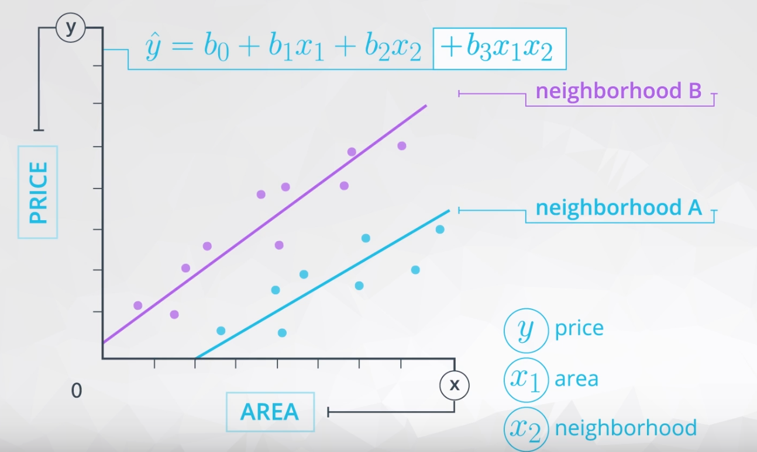](https://classroom.udacity.com/nanodegrees/nd025/parts/6e560cfc-9d0b-4f87-a980-1bf4003b4bc5/modules/e4508dac-d083-427b-be3d-63663aeada68/lessons/49462f74-b030-4bb6-bf67-8281c9181404/concepts/9814e26c-2845-4d09-bf4f-c8d0b4a417de)](https://classroom.udacity.com/nanodegrees/nd025/parts/6e560cfc-9d0b-4f87-a980-1bf4003b4bc5/modules/e4508dac-d083-427b-be3d-63663aeada68/lessons/49462f74-b030-4bb6-bf67-8281c9181404/concepts/9814e26c-2845-4d09-bf4f-c8d0b4a417de)**

These lines might even cross or grow apart quickly. Either of these would suggest an interaction is present between **area** and **neighborhood** in the way they related to the **price**.